**Ai初始的模型方案：**

Here are the potential actors and use cases I identified:

Actors:

- Customer

- Employee

Use Cases:

- Place Order

- Check Order Status

- Cancel Order

- Request Catalog

- Return Product (phone only)

The class diagram could include:

Customer

- customerNumber

- name

- address

- isGoldCustomer

- placeOrder()

- checkOrderStatus()

- cancelOrder()

- requestCatalog()

- returnProduct()

Order

- orderNumber

- orderDate

- productList

- totalCost

- checkout()

- submit()

Product

- productNumber

- name

- description

- price

- image

- availability()

Inventory

- checkAvailability(productNumber)

The sequence diagram for the given scenario would be:

Customer -> Product: getAvailability(#2)

Product -> Inventory: checkAvailability(#2)

Inventory -> Product: unavailable

Customer -> Product: getAvailability(#9)

Product -> Inventory: checkAvailability(#9)

Inventory -> Product: available

Customer -> Order: addProduct(Product #9, quantity=2)

Order -> checkOut()

Customer -> Customer: getShippingAddress()

Customer -> Customer: getBillingAddress()

Customer -> Customer: getCreditCardInfo()

Customer -> Order: submit()

Hope this helps! Let me know if you have any other questions.

**进行优化后的改进方案：**

(1) Use Case Diagram:

```

+---------------------------+

| Order Processing System |

+---------------------------+

| 1..*

|

+---------------------------+

| Customer |

+---------------------------+

| + Place Order |

| + Check Order Status |

| + Cancel Order |

| + Request Catalog |

| + Return Product (phone) |

+---------------------------+

|

| 1

|

+---------------------------+

| Customer Representative |

+---------------------------+

| + Place Order |

| + Check Order Status |

| + Cancel Order |

| + Request Catalog |

| + Return Product (phone) |

+---------------------------+

```

(2) Class Diagram:

```

+--------------------------+ +-----------------------+

| Customer | | Product |

+--------------------------+ +-----------------------+

| -customerNumber: int | | -productId: int |

| -name: String | | -description: String |

| -address: String | | -price: double |

| | | -picture: byte[] |

| +placeOrder(): boolean | | |

| +checkOrderStatus(): | | |

| +cancelOrder(): boolean | | |

| +requestCatalog(): | +-----------------------+

| +returnProduct(): boolean| | Order |

| +getCustomerNumber(): int| +-----------------------+

| +getName(): String | | -orderId: int |

| +getAddress(): String | | -orderDate: Date |

| +getGoldStatus(): boolean| | -totalCost: double |

| | | -customer: Customer |

+--------------------------+ | -products: List<Product> |

| |

+--------------------------+ | +calculateTotalCost() |

| CustomerRepresentative | | +setShippingAddress() |

+--------------------------+ | +setBillingAddress() |

| -customer: Customer | | +setCreditCardNumber()|

| | | +submitOrder(): boolean|

| +placeOrder(): boolean | +-----------------------+

| +checkOrderStatus(): |

| +cancelOrder(): boolean |

| +requestCatalog(): void |

| +returnProduct(): boolean|

+--------------------------+

```

(3) Sequence Diagram:

```

Ali OrderProcessingSystem Customer

| | |

| | placeOrder() |

| |------------------->|

| | |

| | checkAvailability()|

| |<-------------------|

| X | |

Assuming the checkAvailability() method returns that product #2 is unavailable and product #9 is available.

```

| X | |

| | addProductToBasket()|

| |<-------------------|

| | |

| | addProductToBasket()|

| |<-------------------|

| | |

| | confirmShipping() |

| |<-------------------|

| | |

| | confirmBilling() |

| |<-------------------|

| | |

| | confirmCreditCard() |

| |<-------------------|

| | |

| | submit() |

| |------------------->|

| | |

| | orderPlaced() |

| |<-------------------|

```

Note: The X marks the part of the sequence diagram that is not relevant to this specific scenario.

**两个方案的区别：**在初始的方案中，ai只是单纯的识别出了actor和use case的种类，指出了有哪些actor和哪些use case 并没有将两者建立实际的关系，而在第二次进行过修改后，AI能够在指示下生成每一个actor对应的use case 提高了对应的准确性，同时具体的类图和顺序图也在多次迭代中成功生成。进行了多次迭代后的AI对模型的识别会更加精准，同时AI所产生的模型会更加接近我们想要的结果。

**完成用例图：**

所需时间：19min，

共提问次数：3次

**完成类图：**

所需时间：12min，

共提问次数：1次

**完成顺序图：**

所需时间：5min，

共提问次数：1次

**以下是聊天记录**

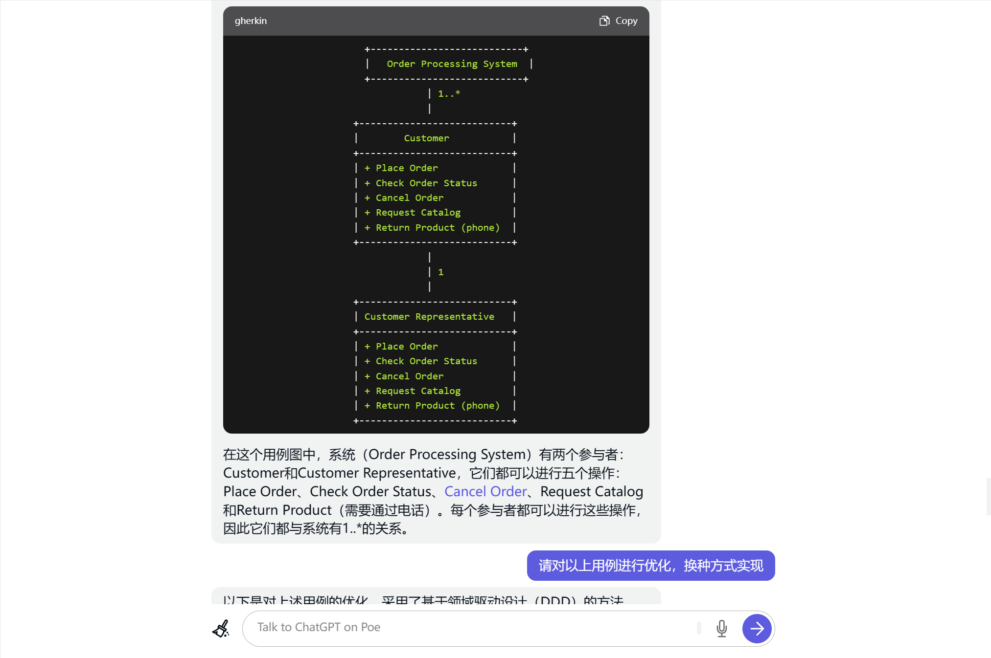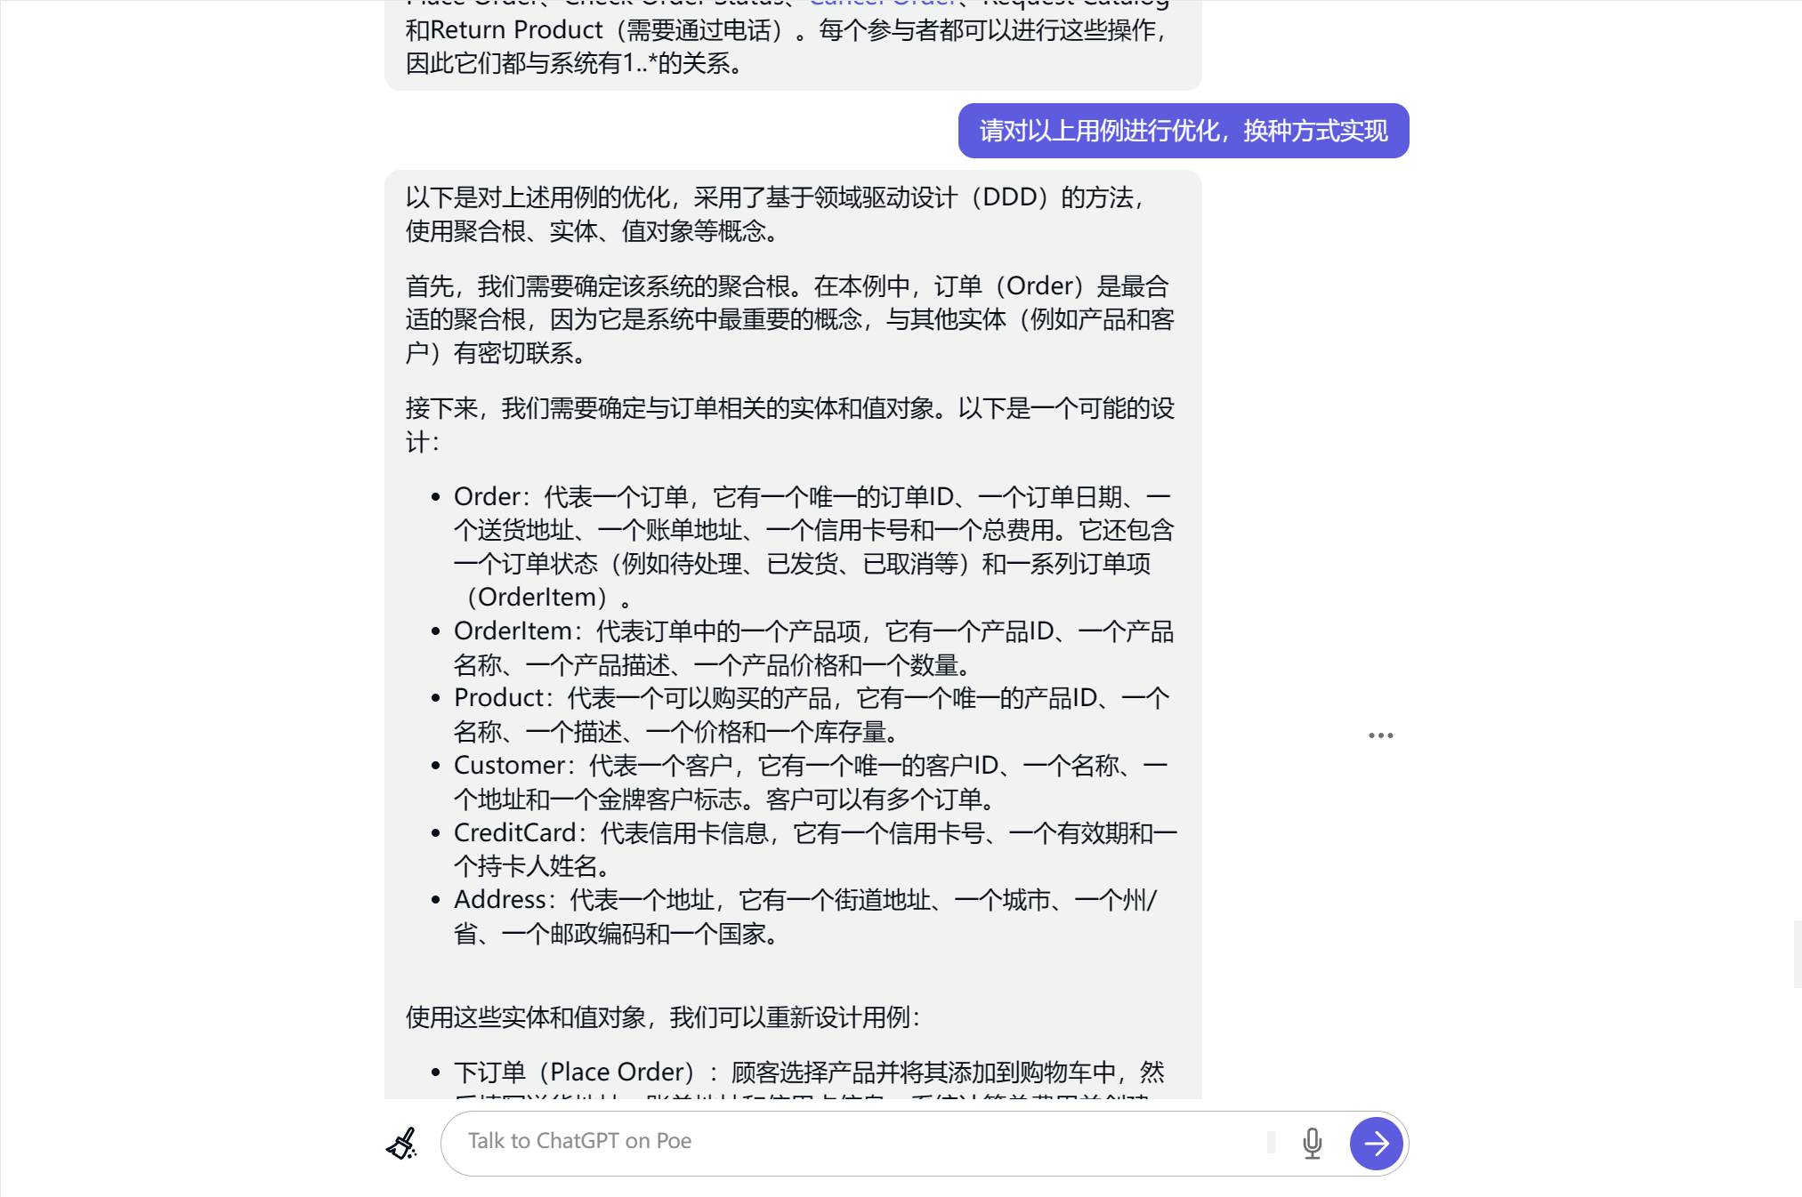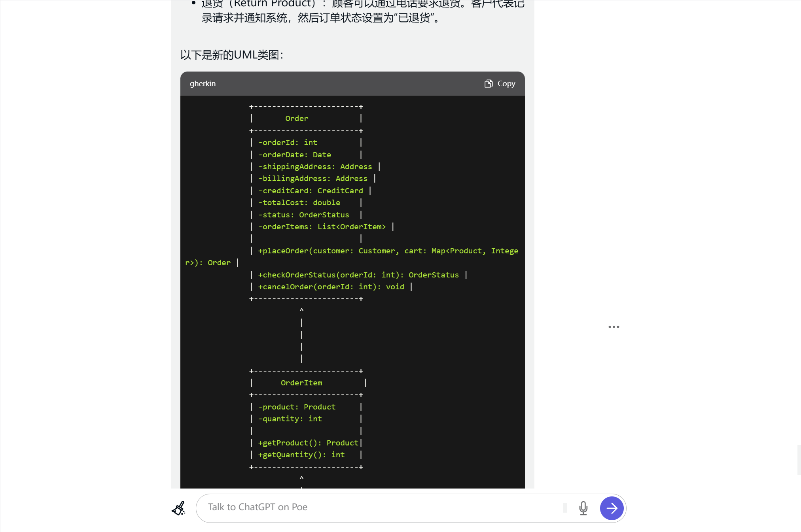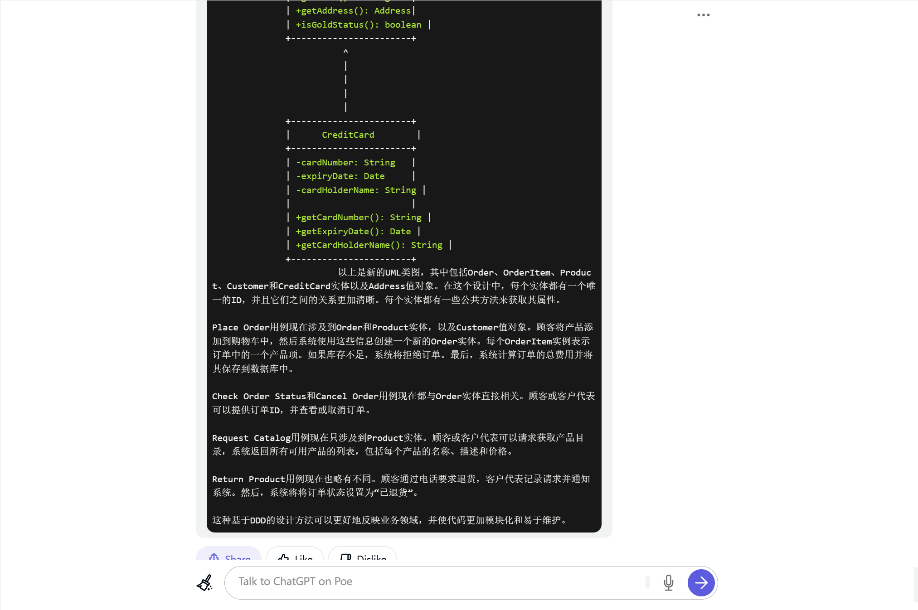

**生成用例图，类图和顺序图的对话：**

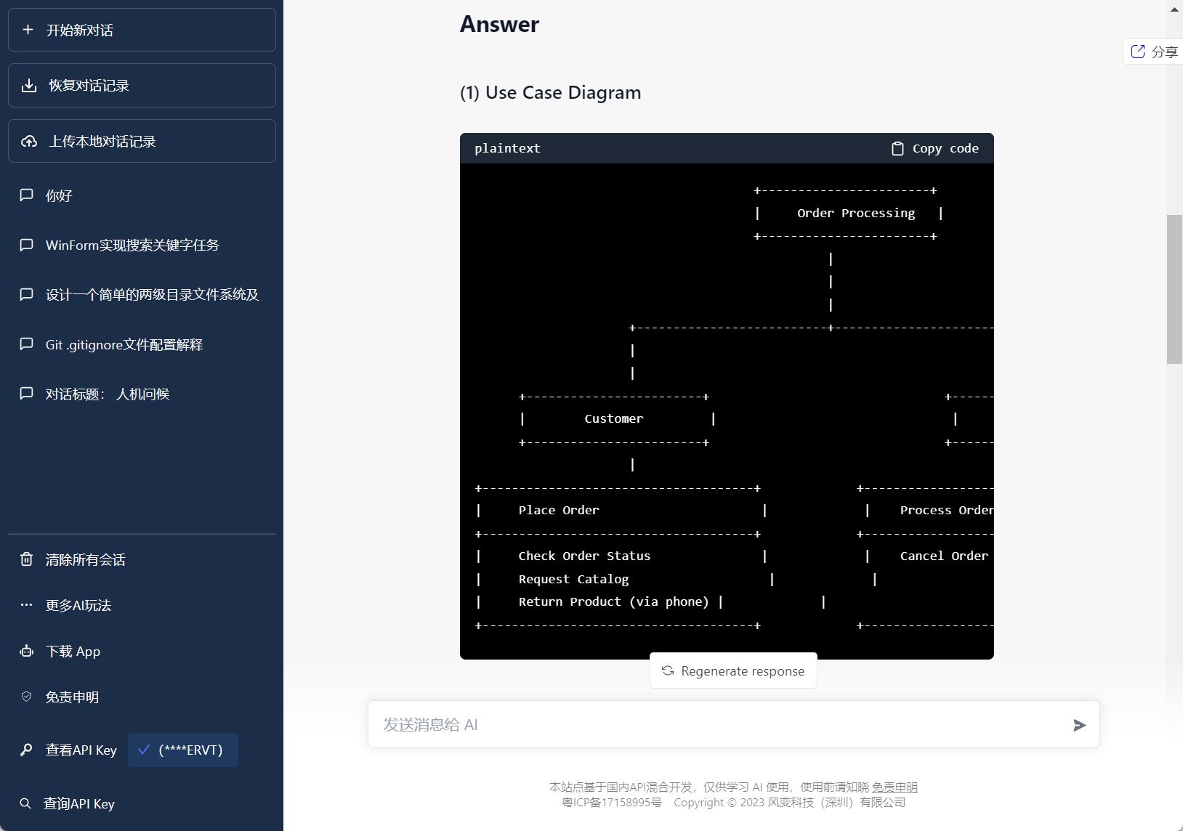 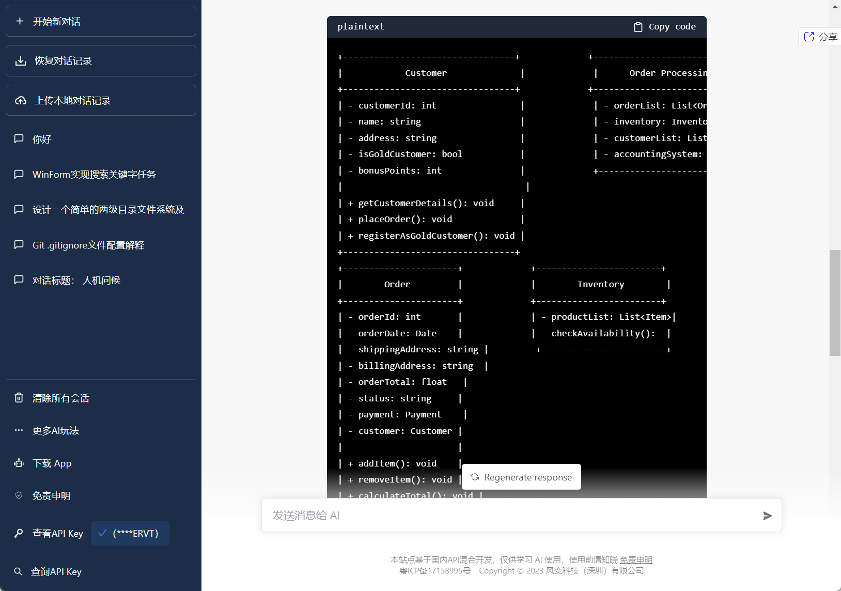 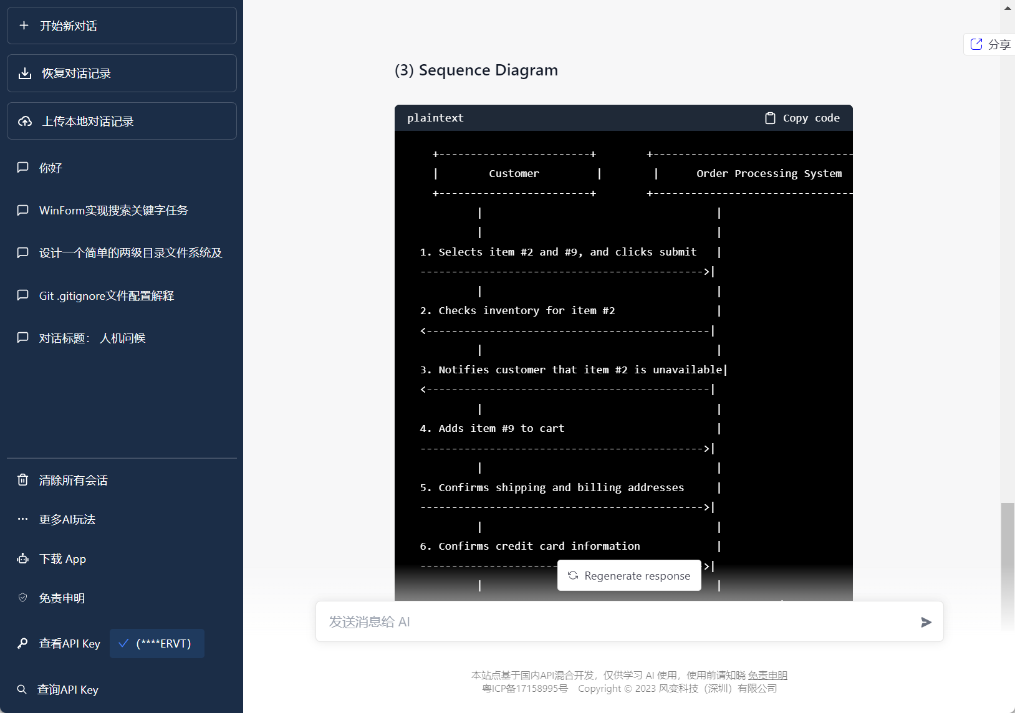

**让AI使用GRASP原则进行类图的优化**

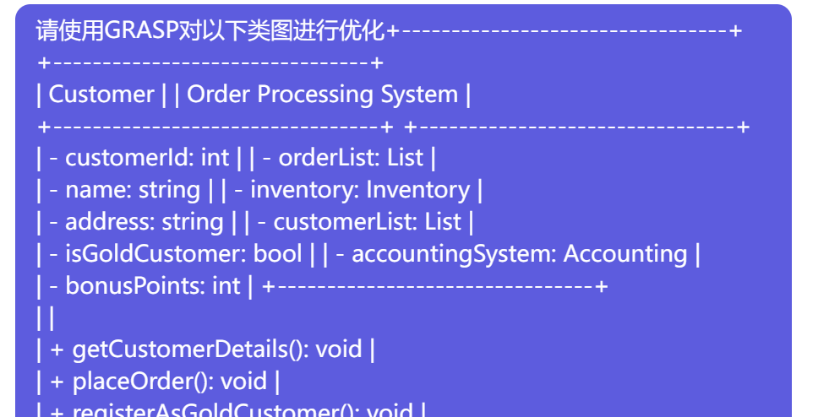

产生的结果：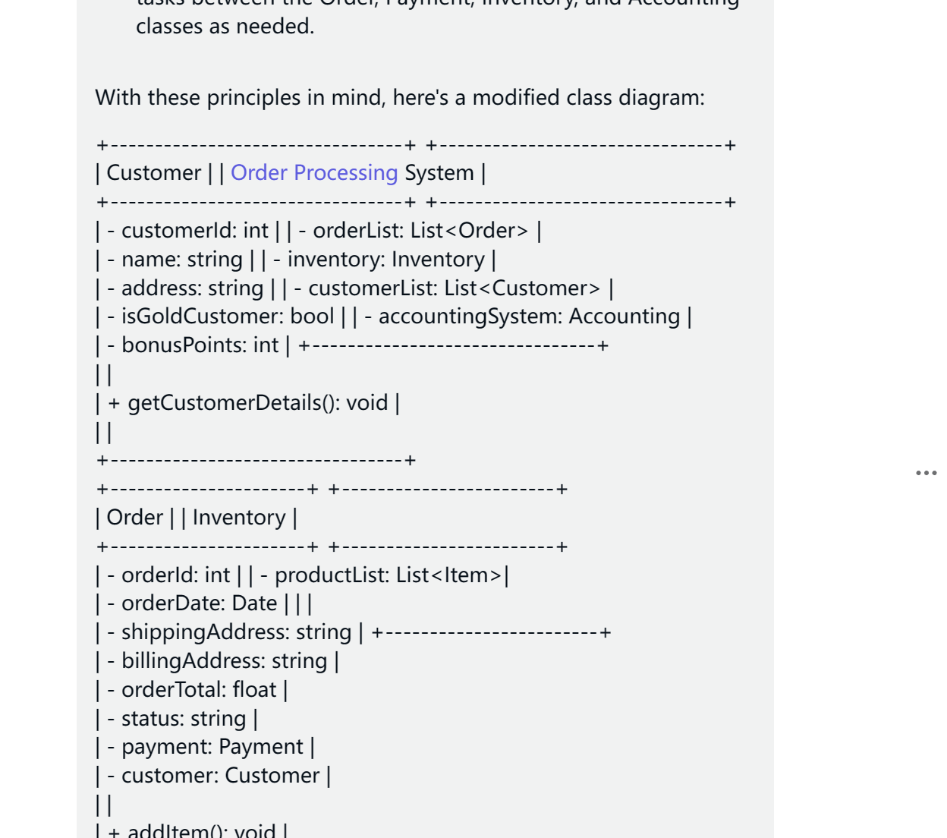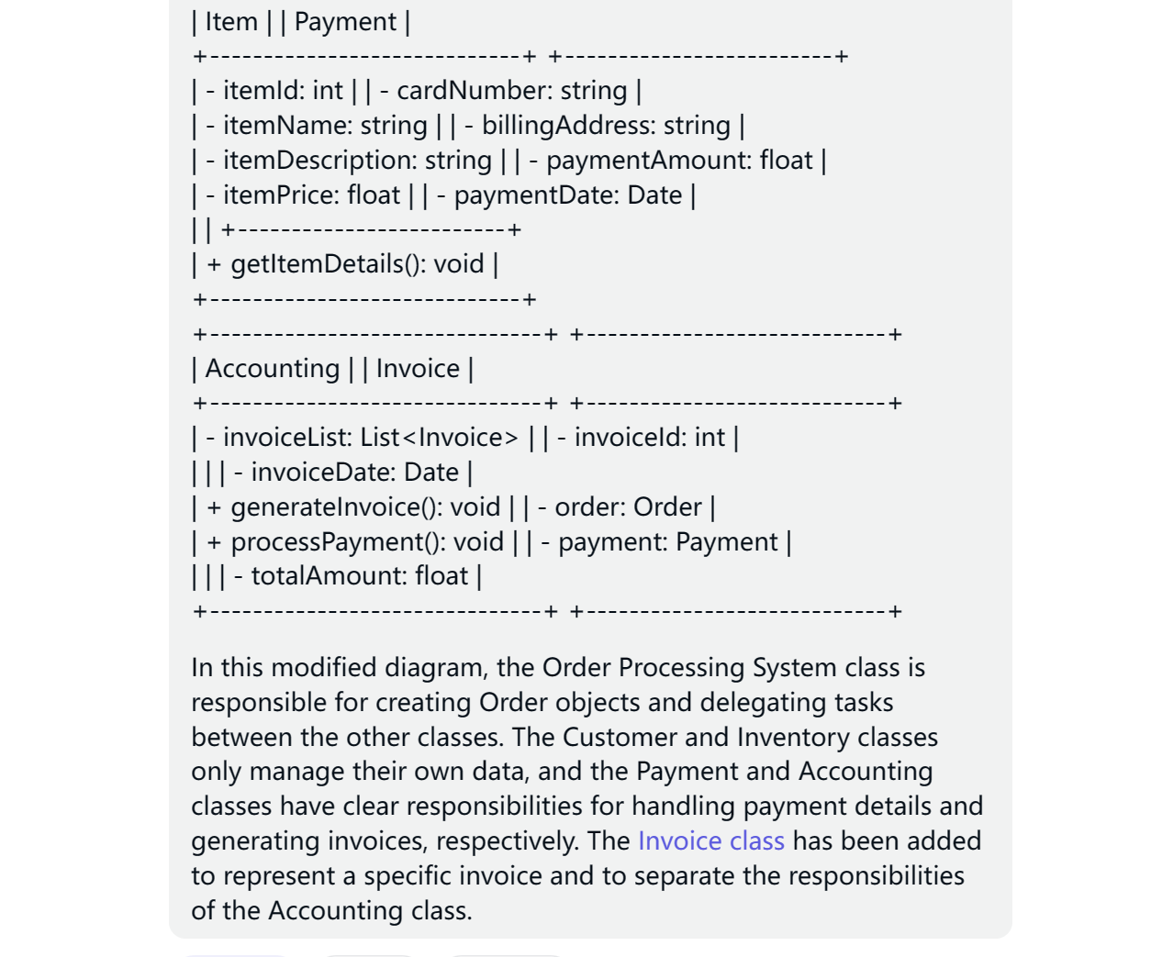

AI对顺序图进行优化：

使用了以下方法进行优化：

控制器：订单处理系统应充当控制器，协调和委派阿里和客户之间的任务。

创建者：订单处理系统应根据阿里和客户提供的信息创建订单对象。

低耦合：订单处理系统不应依赖于阿里和客户的具体方法。相反，它应该使用更通用的“selectProducts”方法，允许阿里和客户向订单中添加产品。

高内聚性：序列图中的方法应该有明确的责任。例如，“confirmShipping”和“confirmBilling”方法应分别负责验证发货地址和计费地址。

